**Lesson 06 Lesson-End Project**

**Continuous Integration with Selenium in Jenkins**



**Steps to be followed:**

1. Logging in to Jenkins
2. Adding TestNG and Selenium dependencies and classes in Maven project
3. Creating a Jenkins job for Maven project
4. Building the Jenkins job

**Step 1: Logging in to Jenkins**

1.1 Open your browser and navigate to **localhost:8080**

1.2 Provide your username and password and click on **Login**

**Step 2: Adding Selenium and TestNG dependencies and classes in Maven project**

2.1 Create a maven project by executing the following command in the terminal of your lab:  
***mvn archetype:generate -DgroupId=jenkinsDemo -DartifactId=jenkinsDemo -DarchetypeArtifactId=maven-archetype-quickstart -DinteractiveMode=false***

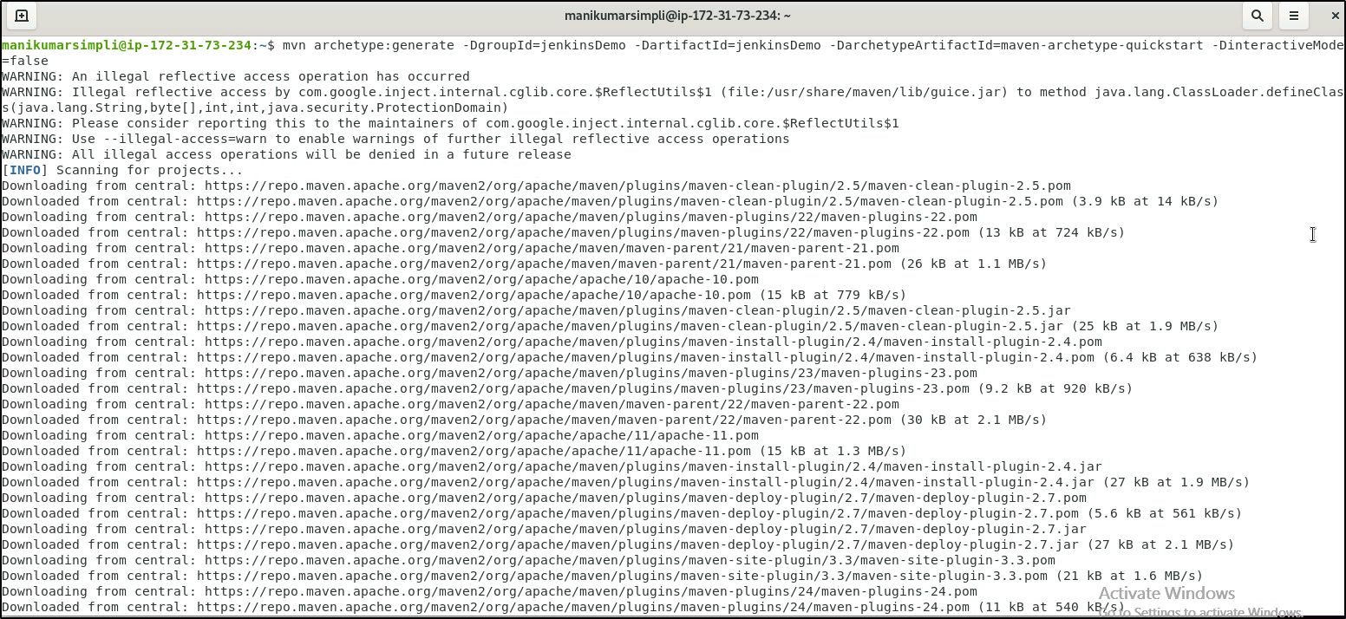

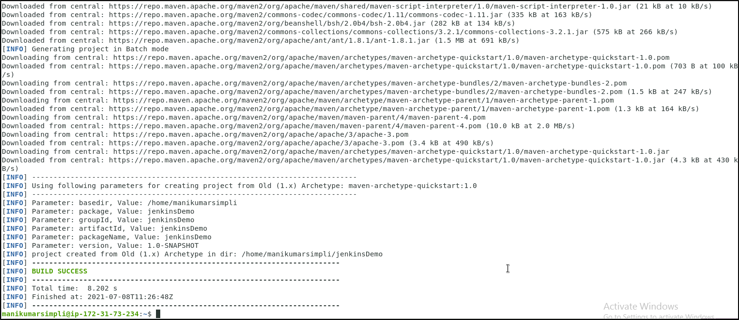

2.2 Run the below commands to navigate inside the maven project:

***cd jenkinsDemo***

2.3 To update **pom.xml** file use the command given below:

***vi pom.xml***

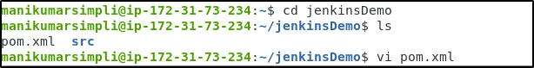

2.4 Add the below code after the url tag in the pom file of your maven project:

***<properties>***

***<maven.compiler.source>1.8</maven.compiler.source>***

***<maven.compiler.target>1.8</maven.compiler.target>***

***</properties>***

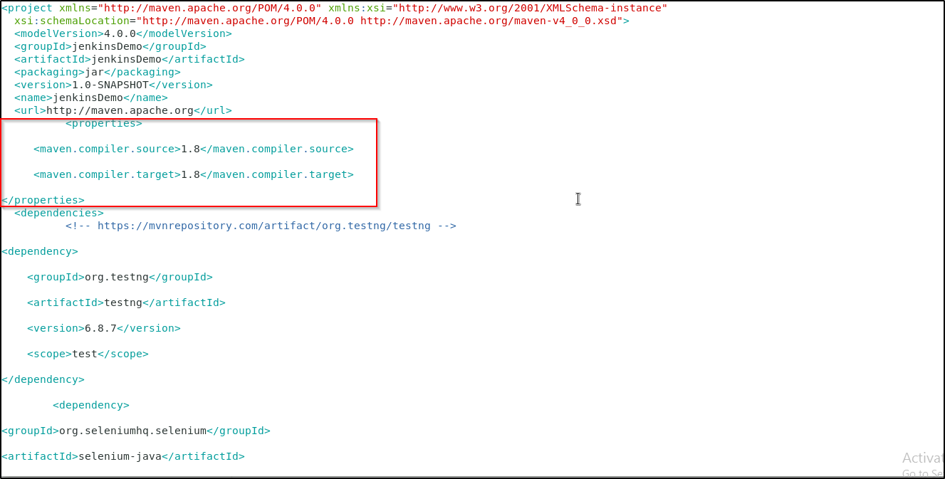

2.5 Add the below code in the **<dependencies>** section of the **pom.xml** file of your Maven project:

***<!-- https://mvnrepository.com/artifact/org.testng/testng -->***

***<dependency>***

***<groupId>org.testng</groupId>***

***<artifactId>testng</artifactId>***

***<version>6.8.7</version>***

***<scope>test</scope>***

***</dependency>***

***<dependency>***

***<groupId>org.seleniumhq.selenium</groupId>***

***<artifactId>selenium-java</artifactId>***

***<version>3.10.0</version>***

***</dependency>***

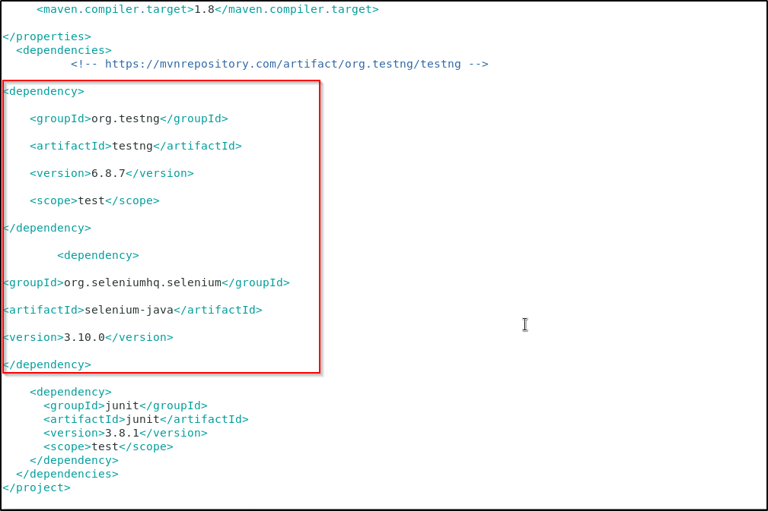

2.5 Save the file and exit using the command **[esc] shift+:wq**

2.6 Delete the src/main folder using the commands given below:

***cd src***

***rm -r main***

2.7 Create a file **JenkinsDemo.java** using the following commands:

***vi JenkinsDemo.java***

2.8 Add the following code in **JenkinsDemo.java:**

***import org.testng.After;  
import org.testng.Assert;  
import org.testng.Before;  
import org.testng.Ignore;  
import org.testngTest;  
import org.openqa.selenium.By;  
import org.openqa.selenium.WebDriver;  
import org.openqa.selenium.chrome.ChromeDriver;  
  
/**  
 * Created by   
 * Sample junit test code to integrate by  
 */  
public class JenkinsDemo  
{  
 private static String Base_Url = "https://www.facebook.com";  
 private WebDriver driver;  
  
 @Before  
 public void setUp()  
 {  
 driver = new ChromeDriver();  
 driver.get(Base_Url);  
 }  
  
 @After  
 public void after()  
 {  
 driver.quit();  
 }  
  
 @Test  
 public void testCasePassed()  
 {  
 Assert.assertTrue(driver.findElement(By.xpath("//form[@id='login_form']")).isDisplayed());  
 }  
  
 @Test  
 public void testCaseFailed()  
 {  
 Assert.assertTrue(driver.findElement(By.xpath("//form[@id='failed case']")).isDisplayed());  
 }  
  
 @Ignore  
 @Test  
 public void testCaseIgnored()  
 {  
 Assert.assertTrue(driver.findElement(By.xpath("//form[@id='ignored case']")).isDisplayed());  
 }  
}***

2.9 Save the file and exit using the **[esc] shift+:wq** command.

2.10 Your directory structure should only have these files.

2.11 Run the following command to delete any unnecessary files or folder structures:  
***rm -r jenkinsDemo***

**Step 3: Creating a Jenkins job for Maven project**

3.1 To create a new job in Jenkins, open the Jenkins dashboard with your Jenkins URL.   
For example, http://localhost:8080/

3.2 Click on **New Item**. Enter the item name, select **Maven Project,** and click **OK**

3.3 Once you click **OK,**the page will be redirected to its project form.

3.4 In the **Build** section of your job, for Root POM give the path of the pom.xml in your local system as shown:   
**/*home/<labsuser>/jenkinsDemo/pom.xml***

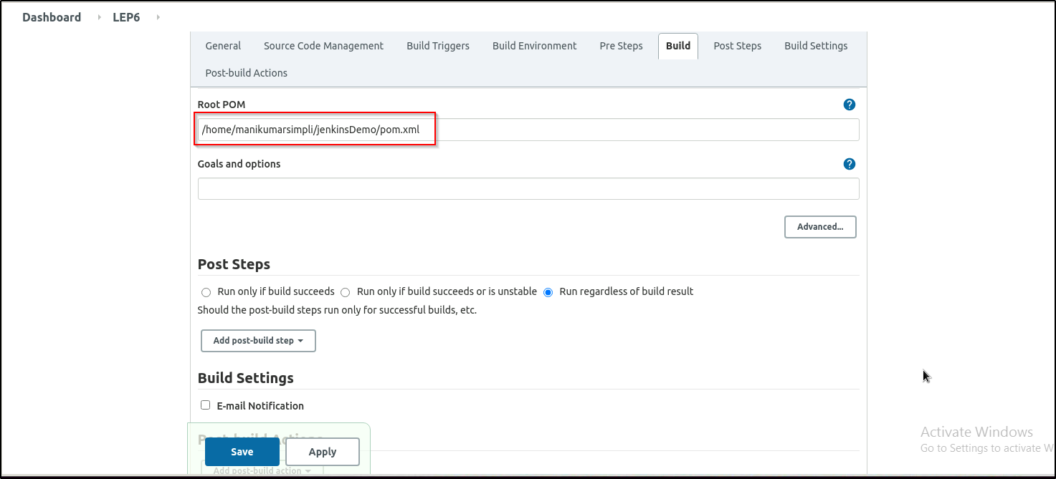

3.5 Click on **Save**.

3.6 Open the terminal and type **sudo chmod -R 777 jenkinsDemo** command.

**Step 4: Building the Jenkins job**

4.1 Click on **Build Now** and check the status by clicking on **Console Output**.

